IT AIN’T EASY BEING GREEN
By Robert “Bob” Kickenweitz

This story is meant to poke fun at myself for being so naïve to the world around us. Please forgive me for some of the situations, as they were all part of the Vietnam experience.

We flew into Tan Son Nhut Air Force Base in Saigon, the capital of Vietnam, on October 11th 1966. At that time we came to Vietnam without a steel pot, flack jackets, but most important of all, no weapon. You see at this time in the war, we were not issued any equipment until you were assigned to a unit. After waiting around in the airport for about half an hour for a bus to pick us up (typical Army hurry up and wait), I needed to use the men’s room. One of my buddies kept an eye on my duffel bag while I ventured on a trip to the men’s room. This was 1966, it was the capital of the country, and the “Pearl of the Orient”, but you would not have known it from the men’s room.

The only thing ceramic in the entire room was the tile floor. A wooden trough fixed to the wall, pitched down to the left acted as a urinal. The most amazing thing to me was, there were no pipes attached to it. When the urine got to the end of the trough, it simply flowed through a hold in the wood and fell to the floor, from the floor it flowed through a hold in the wall. I can’t venture a guess as to where it went from there. This is just not my kind of country!

Another half-hour went by, we were instructed we would have to walk someplace to meet the bus. So off we went, we walked through a tent city, sandbags everywhere, around everything, and everything covered with red dirt. Boy, I’ve been in country one hour and I’m in the boonies already. Little did I know I was still on the air base. We finally found the bus; perspiration dipping off me like an old mop being wrung out, even after my Tigerland Jungle Warfare training in Louisiana during the hottest time of the year I still really felt the heat. All the windows of the bus were opened, but were cover with a wire mesh so that objects such as home made bombs or hand grenades could not be thrown into the bus and ruin our whole day. Being the bright guy I am, I used my duffel bag as a shield placing it in the seat closest to the window, just in case we receive small arms fire I’m hoping the duffel bag would stop the bullets. We came to a stop at a red light in Saigon, two lane of traffic in each direction, a busy street. There standing with his back to the traffic was a Saigon policeman (we use to call them white mice due to their white and gray uniforms). He was urinating on the wall not more then twelve feet away with people going by not noticing a thing. East meets West culture shock!

We continued on our first trip up Highway # 1 past the LBJ Ranch (Long Binh Jail) to the 90th Replacement Battalion at Long Binh. In October of 1966 it was mostly tents, with the exception of the mess hall, and the enlisted men’s club. One night after dinner, I deposited some of my money in the one armed bandits at the enlisted men’s club. I returned to my tent, it was a hot night and the sides of our tent were rolled up. I sat down on my bunk to write some letters home to my family. While sitting there thinking of something to write, I notice my arms had an orange tint to them. Turning to the left I saw this enormous column of flames going up in to the air about two to three hundred feet, then folding over itself churning and boiling to crating a mushroom shaped fire inferno. The ammunition dump across a gully from us had suffered a direct mortar hit. The first thing that popped into my head was “O shit! Charlie is now using atomic bombs!” All those visions of Hiroshima and Nagasaki that we used to see on TV growing up raced through my head in a nanosecond. I grab the mattress at the end of my bed and rolled it around me and became a pupa in a mattress cocoon. Within seconds the shock wave rolled up the gully and hit the tent, making it sway about a foot. I felt very vulnerable not being able to defend myself. I’m not in the country a week, how am I going to last a year over here. Wail I was in Vietnam, this ammunition dump was blown up four times and I was close by on all four occasions.

After a few days went by I got the word I was being assigned to a new unit that arrived in Nam just a little over a month ago, it was the 11th Armored Cavalry Regiment (Blackhorse Regiment). I’m not sure if it’s a set speech, and I have to paraphrase it, but the officer said the following: “Gentleman welcome to the 11th Armored Cavalry Regiment (Blackhorse). We will be going into areas where it will be just the enemy and us; we expect you to fight and fight hard, because if we go down we all go down together”! That was an eye opener. We were placed in a deuce and a half for our short ride over to the Blackhorse Regiments staging area. The staging area was located in Long Binh, and was our base camp while we were building our new base camp in Xuan Loc. I was assigned as a scout and had to provide coverage on convoys to Xuan Loc in the afternoon and back to Long Binh the following morning. Later in my tour of duty, the convoys would leave in the morning and return in the afternoon of the same day. The scouts had a jeep with an M-60 machine gun on a stand behind the two front seats, sandbags ran across the front of the jeep where the windshield would normally be mounted.

My first trip up to Blackhorse was uneventful; we arrived about four o’clock in the afternoon. On the eastern side of Route # 2 was a rubber tree plantation and on the western side, our engineers had cleared a strip of land which was to be the eastern side of base camp. It was about fifty yards wide and about a quarter mile long. This strip grew day by day into Blackhorse Base Camp. After dinner we sat around and talked and joked as most guys do. When it was time to turn in I found a spot under a deuce and a half to sack out. No sleeping bag, no blanket, right on the ground. When morning came, I was afraid to move, I opened my eyes and looked all around making sure some kind of friendly critter didn’t use my warm body to keep themselves comfortable, i.e. a snake! Like I said it was uneventful.

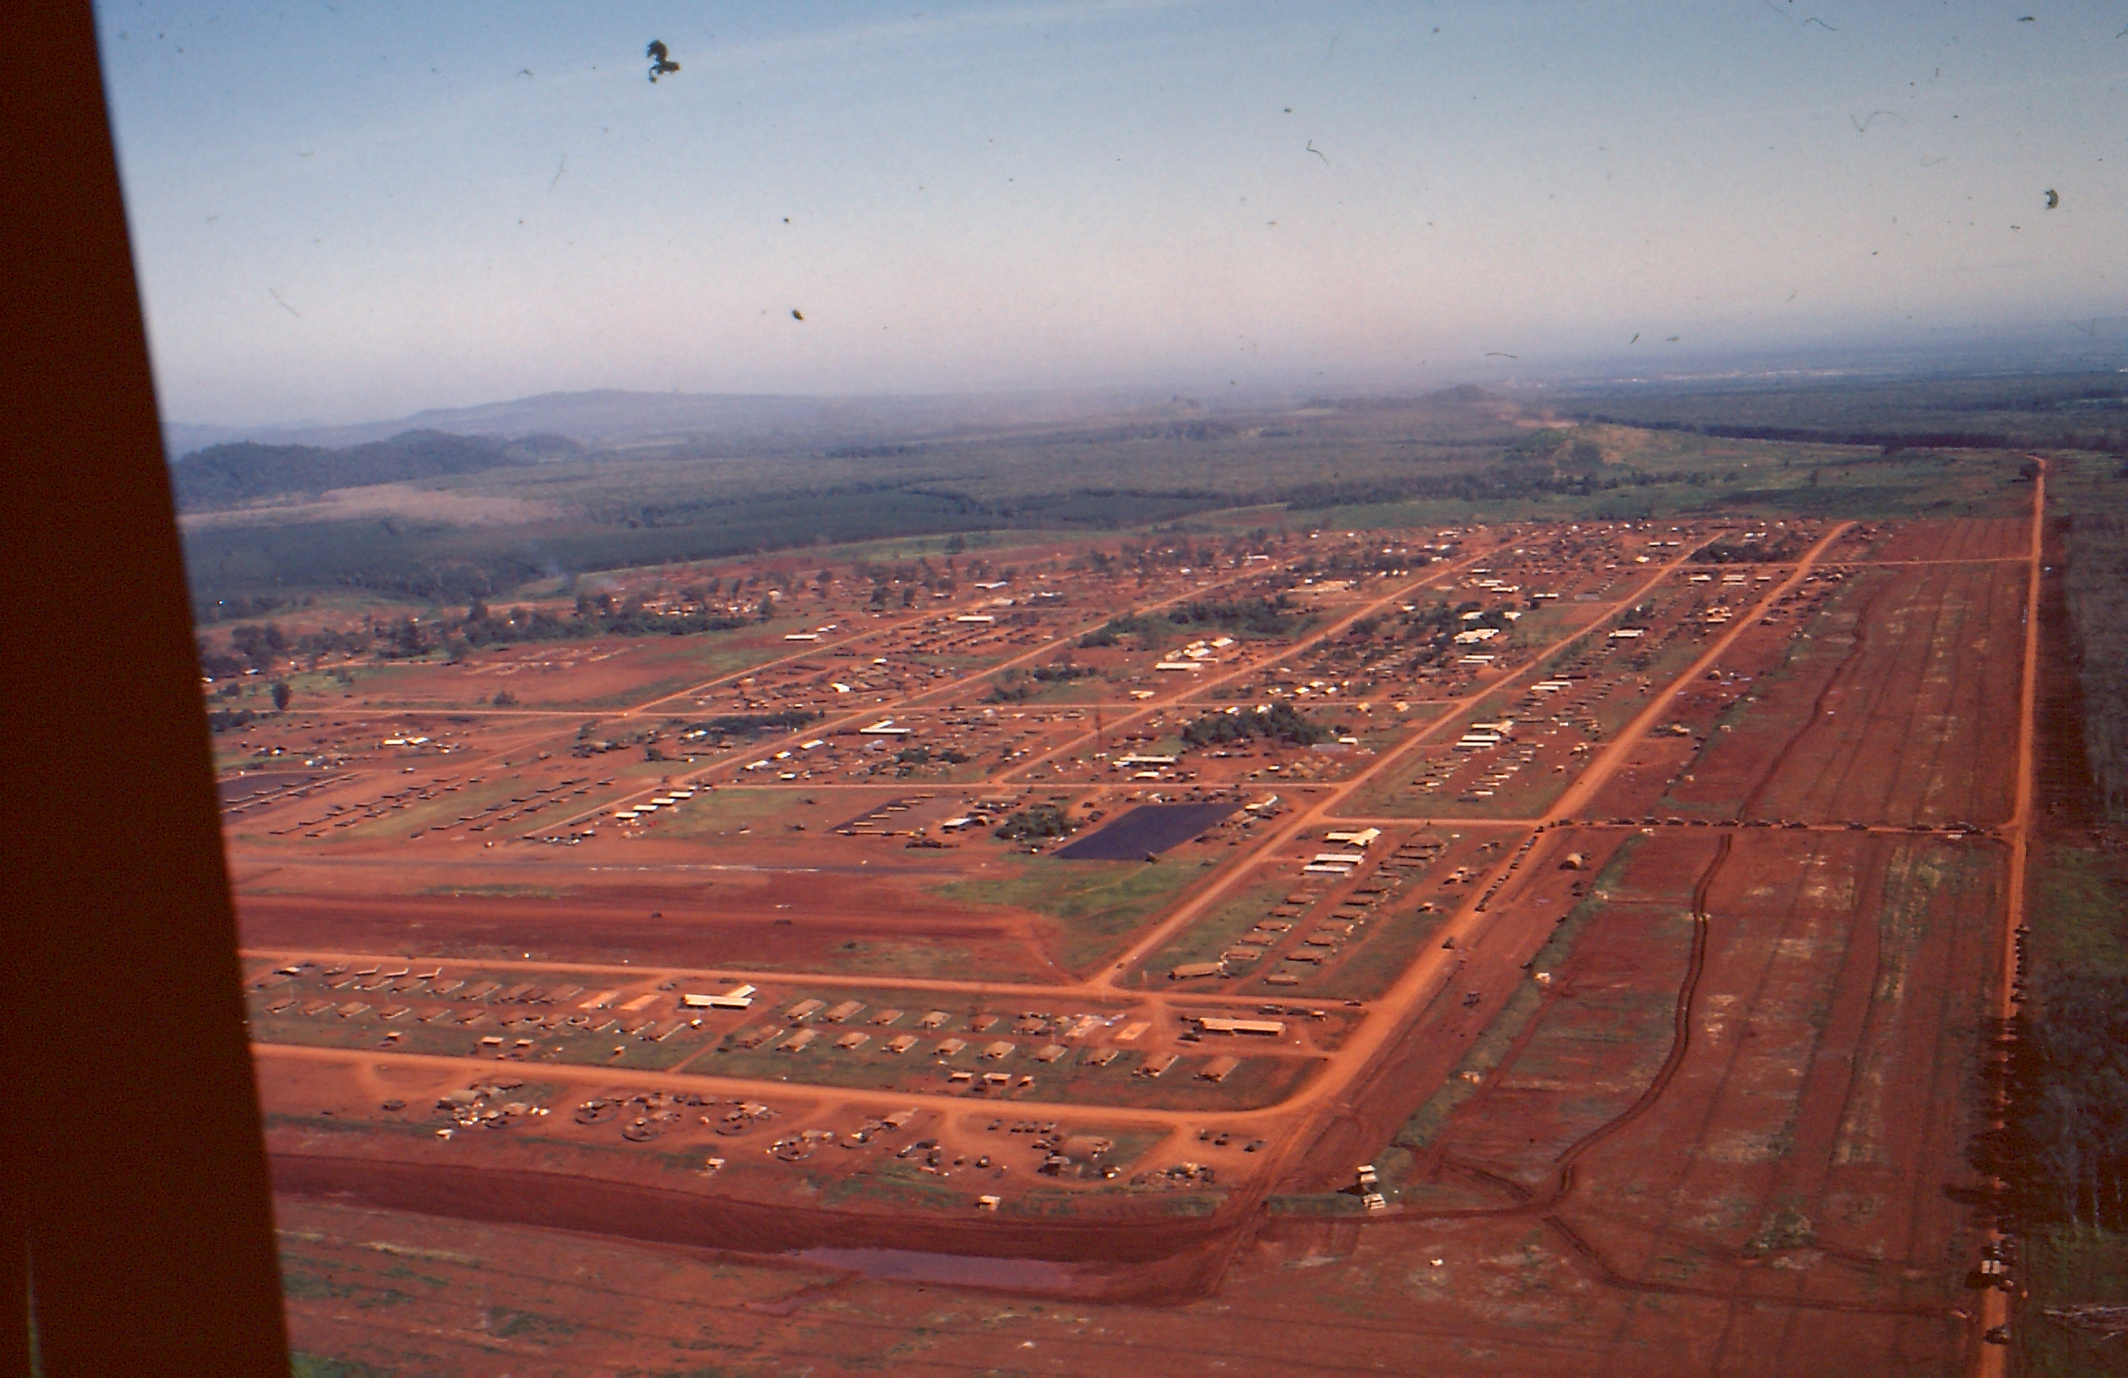

Blackhorse Base Camp

